HEALTH RECOMMENDER SYSTEM

TEJASVI VERMA SONA
20601012023 19601012023
Department of Computer Science & Engineering Department of Computer Science & Engineering
IGDTUW ,Delhi , India IGDTUW ,Delhi , India

ABSTRACT

The Comprehensive Health Recommender System employs machine learning to provide personalized recommendations for medicine, prescriptions, disease management, workouts, and diet based on patient symptoms. This advanced system harnesses big data and sophisticated analytics to analyse user-reported symptoms, enabling it to deliver tailored advice across multiple health domains. By integrating machine learning algorithms, the system categorizes symptoms and aligns them with the most relevant treatments, exercises, and dietary plans, offering holistic support for patient well-being.

Keywords: Recommendation system, Machine learning, Medicine, Healthcare, Research Paper, Technical Writing, Science, Engineering and Technology

- INTRODUCTION

In such a fast-moving world, it is difficult to visit doctor for minor symptoms as people are caught up in their day-to-day life. The COVID-19 pandemic has only made things worse for the healthcare system, putting unprecedented strain on medical personnel and supplies to deal with patient surges and shortages of capacity medications. Hence, a lot of people turned to self-medication worsening their health conditions as there has not been an official medical guidance from healthcare services. The reality of these circumstances is yet again proof for the urgent requirement for obtainable and authentic health services which could also help people with decisions in relation to their health.
High-quality care requires precision medicine, an approach that customizes each patient's treatment. Artificial intelligence (AI) has unleashed the potential of computer applications in healthcare

In this work, we present a Holistic Health Recommender System H2RS to make personalized recommendations for medicine, prescriptions, disease management as well as workout and diet that is tailored specifically from the self-reported symptoms of users using AI. By combining input data obtained from the sensory device and medically verified treatments & lifestyle modifications, this system offers a useful tool both for patients as well healthcare providers.
The rise of the digital age has brought with it one big and HUGE question — can we trust health information found online? Research suggests that many adults use the internet to try and self-diagnose or treat ailments without necessarily consulting a professional. This tendency emphasizes the value of intelligent recommendation systems that provide reliable data-driven advice to users bogged down by information overload.

Recommender systems (RS) are considered to be the most popular application area of artificial intelligence and a great number of machine learning algorithms have been proposed to achieve better RS performance. The real issue is deciding on the best algorithm that can give accurate recommendations according to individual preferences of users. In the field of healthcare, recommender-system-based on medication is an essential way to support professionals in identifying and selecting possible treatment alternatives.
In this work, we mitigate these issues by presenting a Health Recommender System that leverage machine learning methodologies to evaluate thousands of historical medical data and generate specific health recommendations. The idea is that the tool will not only help an individual user fitting to make informed health choices as about other tools, but also provide assistance in healthcare professionals, chemists and nurses.

Recommendation systems (RS) have become famous in the field of nurses for recommending right treatments to patients especially award medico less availability. Our goal with this system is using AI and big data to democratize healthcare.

- METHODOLOGY
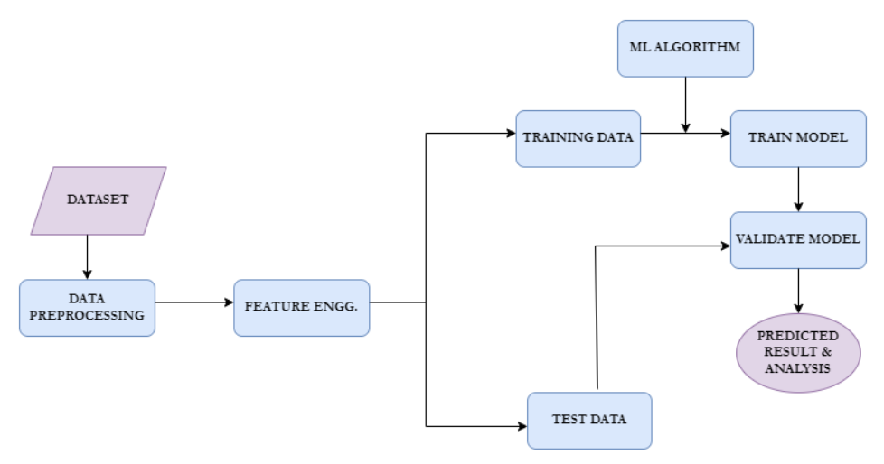
1.DATA COLLECTION & PREPROCESSING
Machine learning model needs a lot more data to work. Data acquisition for the purpose of this project will mean collecting signals that quantify real-world phenomena, and converting these measurements into a digital format suitable for processing by a computer. Getting this first part right is important in order to create a functional system that can correctly understand and act on the messages input by users.
Preprocessing: To deliver suitable consistency and reasonable accuracy, raw data is collected after preprocessing. That means cleaning the data to get rid of inaccuracies, inconsistencies and missing entries — an important job because real-world data is often spotty or even patchy. By preprocessing, this "dirty" data is into a clean and usable dataset so that it becomes easier to match individual.. responses accurately for the comparisons ever done.

2.FUNCTION SELECTION & DATA PREPARATION
Data Preparation and Feature Selection
Feature Engineering is a process of optimizing the performance of machine learning algorithms by extracting features from the data. We can then use domain expertise to create targeted features which improve the predictive nature of our wonderful model. It requires that you process raw data into contextual features which capture more of the health state or symptoms.
As feature engineering has direct effect on the outcome predicted by model, it becomes integral to a machine learning programme. Data classification, or the process of grouping and categorizing data into different sections based on distinctive attributes (i.e. sickle cell anemia) further inhibitors the input provided to model as it needs clear distinctions between various health conditions in order to determine successful referrals for each case with high specificity
Model Building and Training
The training of a machine learning model consists

3.MODEL BUILDING AND TRAINING
Model Building and Training
Machine learning model is trained using a training dataset that acts as input to the algorithm for supervised learning. This process allows the model to identify any associations between input data (like symptoms) and target outcomes like treatments or lifestyle changes. This process produces the machine learning model, which contains all these patterns learned.
The generalization ability of the model is determined by how well it can generalize from seen training data to unseen test samples. Once the model understands which relationships to use in matching input features with expected outcomes, it can recommend actions across medicine, prescriptions, disease management options, workouts and diet.

4.MODEL VALIDATION & RESULT EVALUATION
A separate portion of data was necessary to test and review this model for accuracy in order to gauge it's general success. In order to make sure that the model can generalize well into real life, there would be different data sets for training and testing. Once the model is evaluated, we deploy it and then make predictions on the real-time.
Those predictions will then be examined to determine which elements contribute most to the outcomes. This step is important to narrow in on the model, and ensure it produces an accurate prediction tailored towards the symptoms of that individual user's own unique health profile.

- RESULTS AND DISCUSSION

The web application, "Health Hub" built on a Support Vector Classification (SVC) model and predicts the likelihood of diseases given user-reported symptoms. The application also shows a description of the projected disease and gives all necessary information (precautions, equipment, medication) connected with it.
1.Functionality:
The SVC model predicts, using a binary-vector from the user symptoms typing into integer form and it reversed to detect disease.
2.Retrieve information: After a disease is predicted, the app reads and displays more related data of multiple datasets. The information includes:
Abstract and brief description of the disease
Precautions: Suggested measures to avoid or control the disease
Drugs: Drugs are the most common form of treatment for lupus.
Dietary advice: Ways how diet could help to live with the disease.
Physical Training: Exercises that might help the disease
3.A unique user interface: The UI of the web application is quite modern and intuitive, built in HTML paired with Bootstrap.
Result section: This shows predictions of disease along with multiple modals that give each information about predicted diseases.
4.Performance:
Accuracy Depends on data quality and model updates
Design & User Interface: It has a sedulous design and modal windows that provide copious information to the user.
5.Limitations:
Limitations on accuracy and coverage are imposed by the dataset (3) 2016 version, symptom-disease mapping.
Future Improvements: Model Refresher with more data in updating the model and Symptom Extension

The "Health Hub" application successfully integrates a machine learning model with a web-based interface to provide disease predictions and relevant health information based on user-reported symptoms. The system demonstrates practical applications of machine learning in healthcare and offers a solid foundation for further development and improvement.
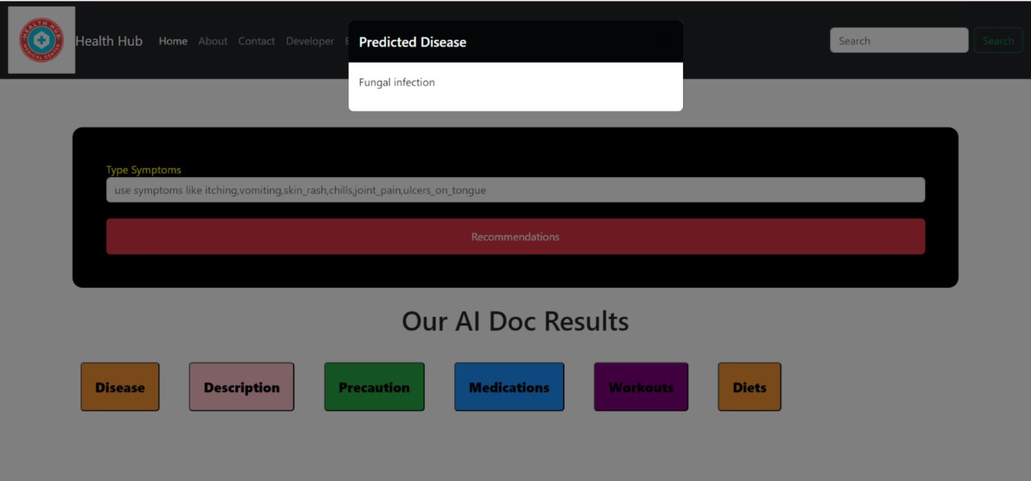
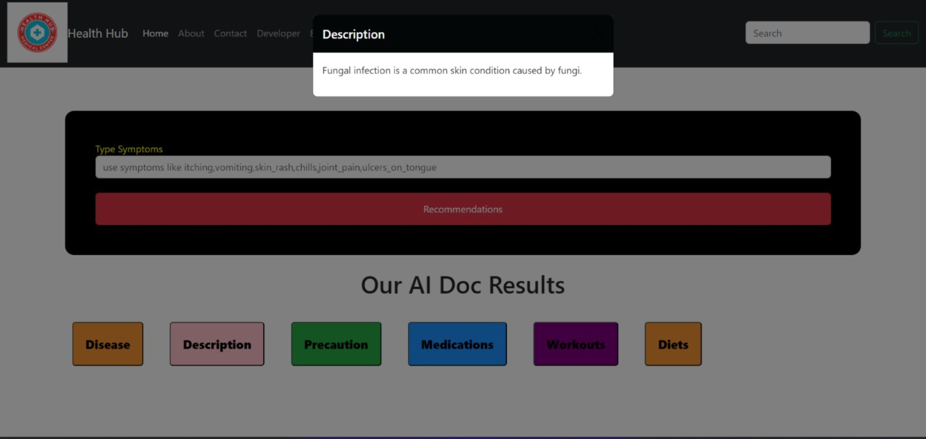
image-1
image-2

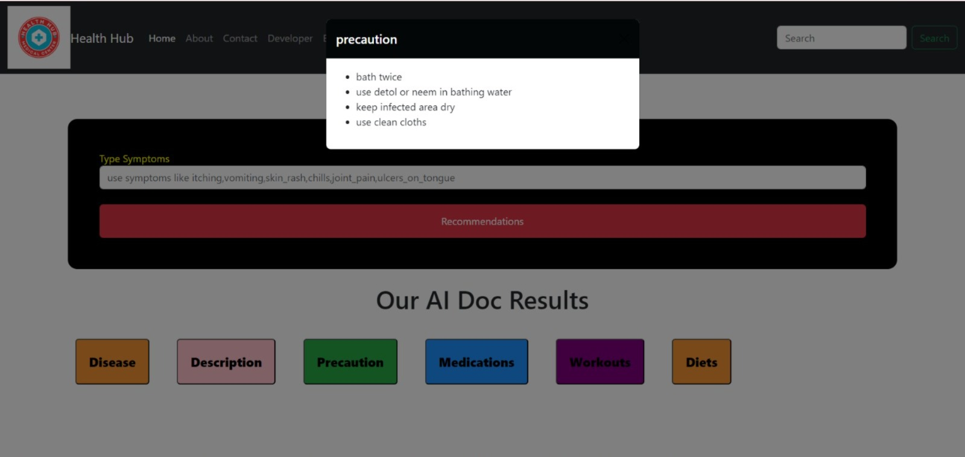
image-3
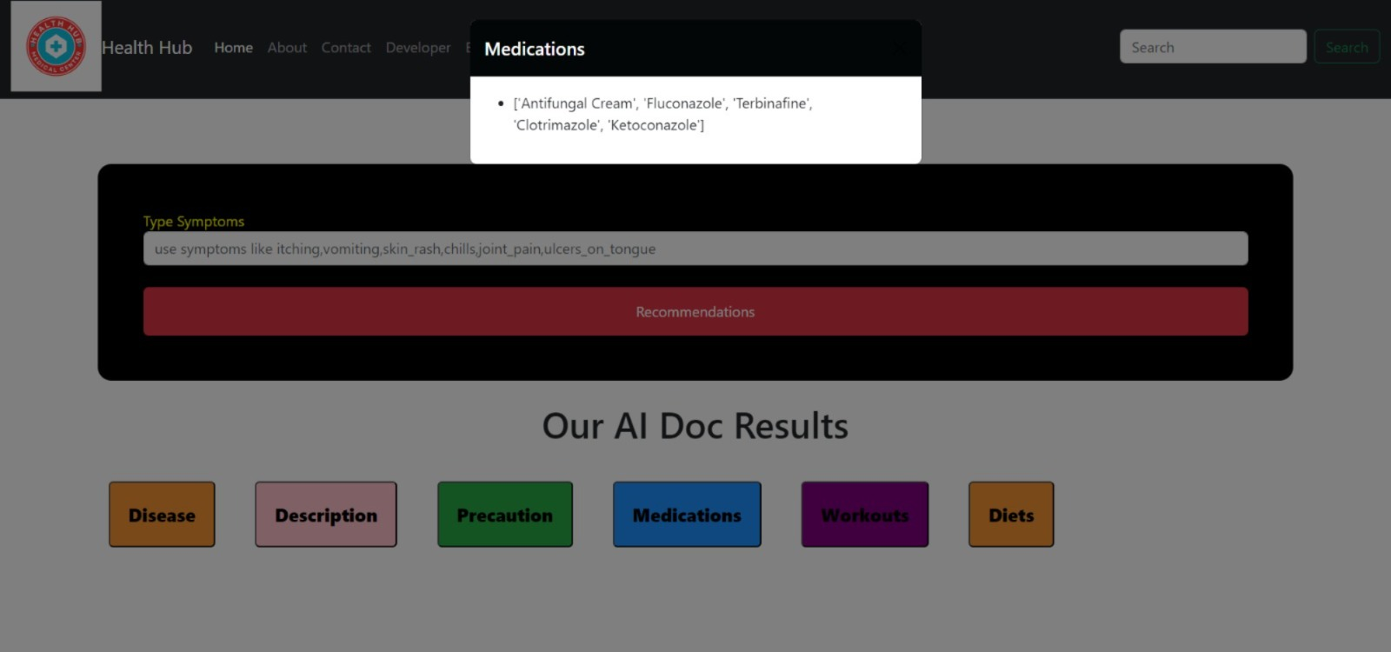
image-4
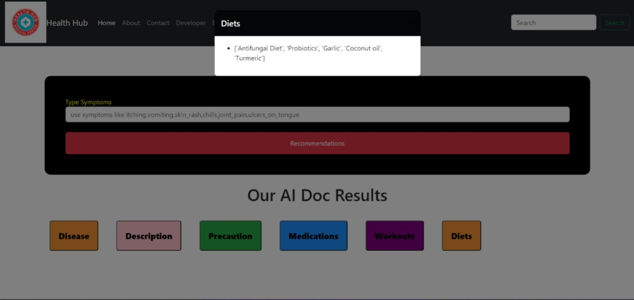
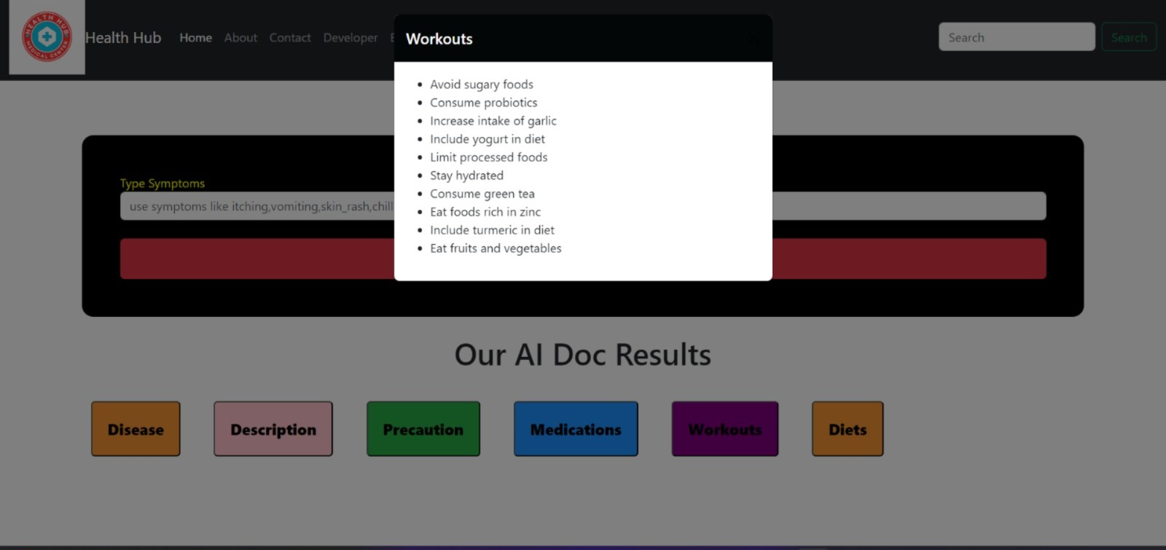
image-5
image-6

- CONCLUSION
Health Recommender System: We propose a Health recommender system, using machine learning which would provide recommendations for medicines, prescriptions & disease management as well workouts and diet based on the symptoms of diseases. It was developed in response to the increasing demand for easily accessible healthcare solutions especially when it is not possible or practical, due to time constraints and limited medical resources, even visiting a doctor.
We took a lot of care to collect the proper data and preprocess, feature engineering making sure that model was 100%. Training the model on a diverse and comprehensive dataset allowed us to build an architecture that has been able to analyze symptoms and propose health interventions fit for them.

Model evaluation suggested that the model can generalize to new data, and make accurate individualized recommendations which could improve patient outcomes. Whether a person with diabetes chooses to take the advice on board is another matter, but AI and ML have shown they could democratize healthcare by delivering more nuanced personal health advice alongside these methods. We are excited to introduce the Health Recommender System, which not only empowers people with data driven recommendations about their health and well-being but also provides a critical decision support mechanism for healthcare providers in order to enable them provide highly specific evidence based information.

- REFERENCES

[1]https://www.researchgate.net/publication/366303205_Medicine_recommender_system_A_machine_learning_approach

[2]https://www.irjmets.com/uploadedfiles/paper/issue_7_july_2023/43424/final/fin_irjmets1690118387.pdf

[3]https://ijsrset.com/paper/8152.pdf

[4]https://www.ijnrd.org/papers/IJNRD2402259.pdf

[5]https://www.researchgate.net/publication/360144390_Recommender_system_for_health_care_analysis_using_machine_learning_technique_a_review

[6]https://shanlaxjournals.in/journals/index.php/sijash/article/download/6344/5878/

[7]https://ieeexplore.ieee.org/document/10051457

[8]https://ijcrt.org/papers/IJCRT2303080.pdf

